Program no: **01**                        Program Title: **LED BLINK**

**Aim:**To control the LED using Arduino ( to turn ON/OFF LED)

**Hardware/components Required:**

* Arduino Uno board - 1
* USB Cable - 1
* LED - 1
* Jumper wires

**Circuit Diagram / Pin connection:**

* LED's positive leg is connected to digital pin 13.
* LED's negative leg is connected to ground.

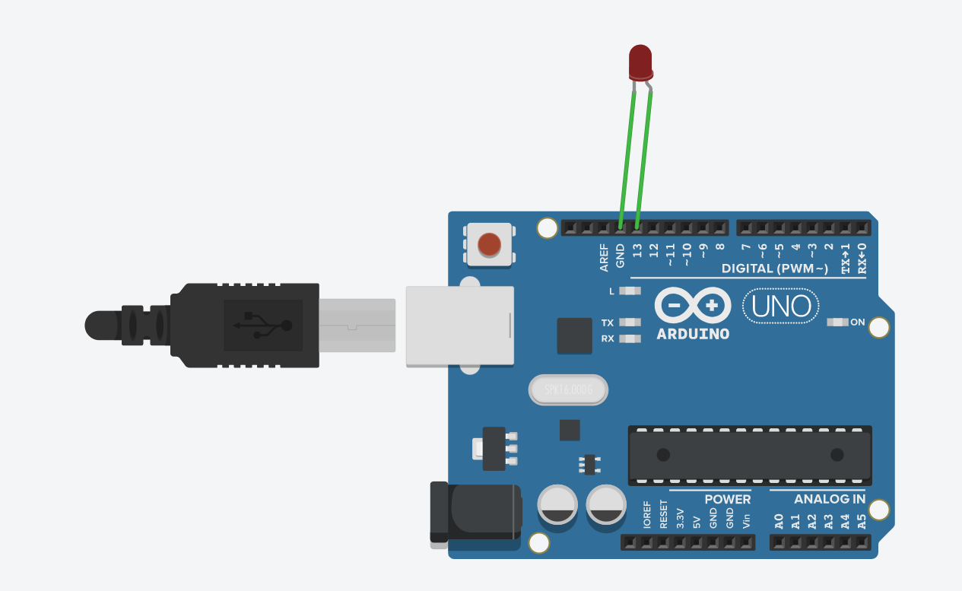

**Handwritten code pic:**

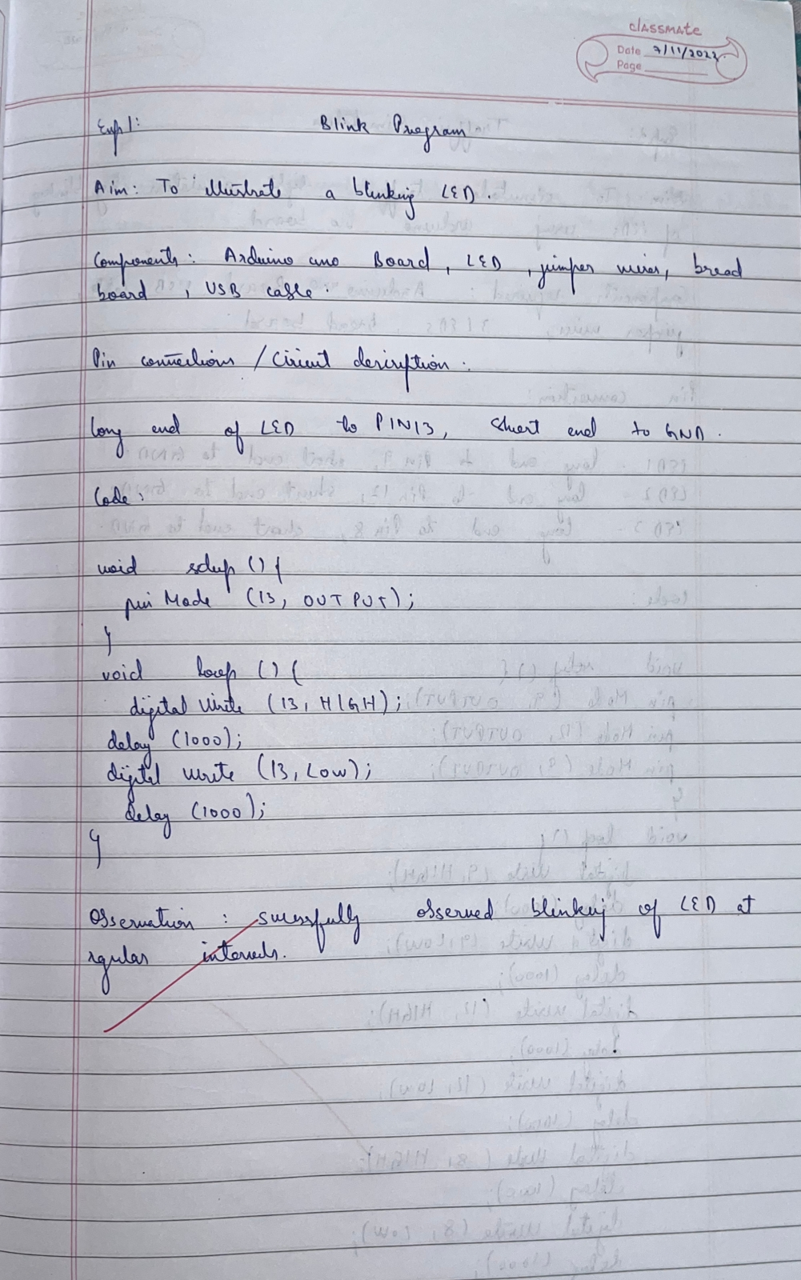

**Code:**

void setup() {

pinMode(13,OUTPUT);

}

void loop() {

digitalWrite(13,HIGH);

delay(1000);

digitalWrite(13,LOW);

delay(1000);

}

**Observation:** LED switches ON/OFF periodically. Digital output visualization using Arduino Uno.

Program no: **02**                        Program Title: **Traffic Light Simulation**

**Aim:** To simulate traffic lights by blinking of LEDs using Arduino Uno board

**Hardware/components Required:**

* Arduino Uno board - 1
* USB Cable - 1
* LEDs - 3
* Jumper wires
* Bread Board

**Circuit Diagram / Pin connection:**

* LED 1’s positive leg is connected to digital pin 13, negative end to ground.
* LED 2’s positive leg is connected to digital pin 13, negative end to ground.
* LED 3’s positive leg is connected to digital pin 13, negative end to ground.

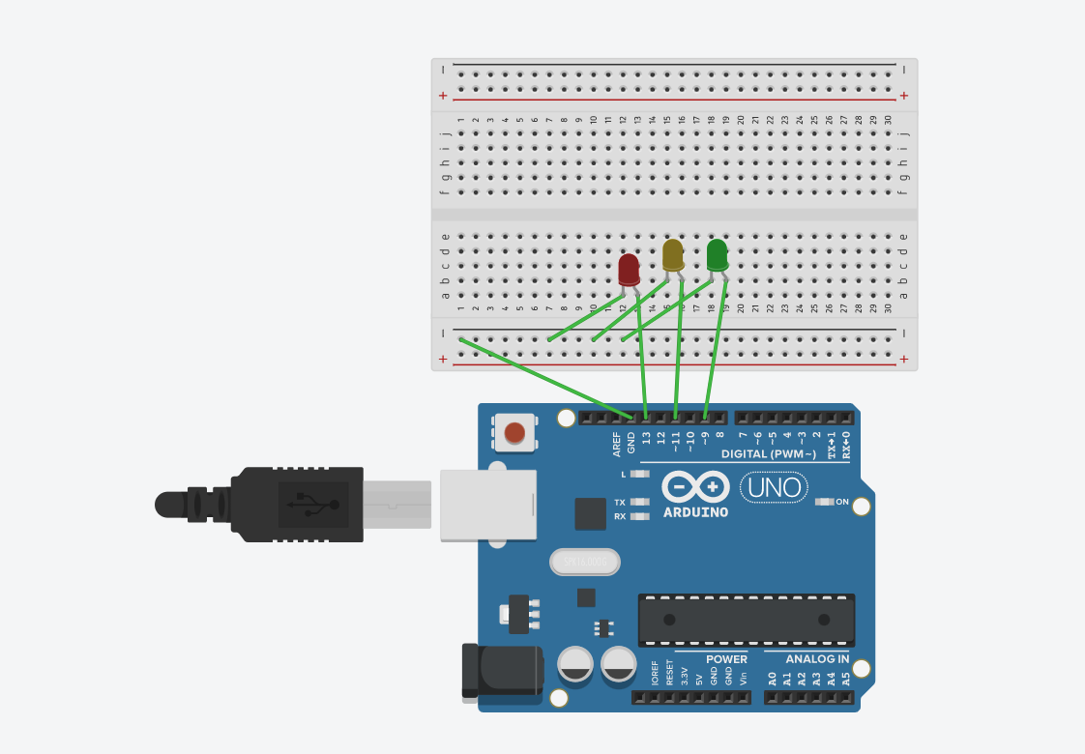

**Handwritten code pic:**

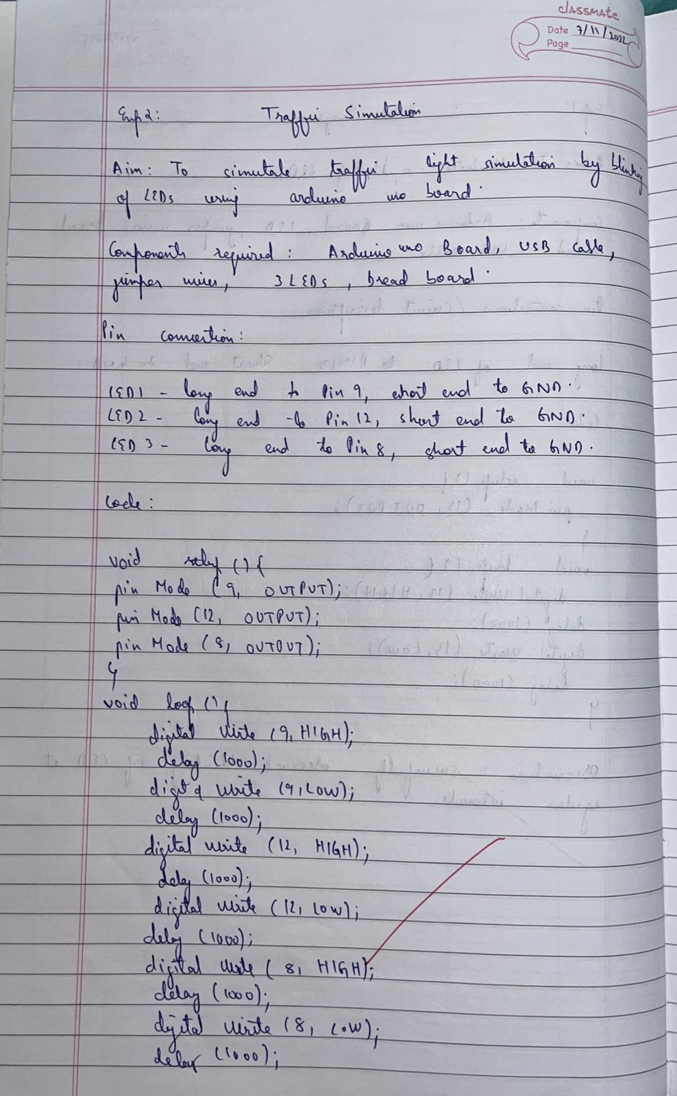

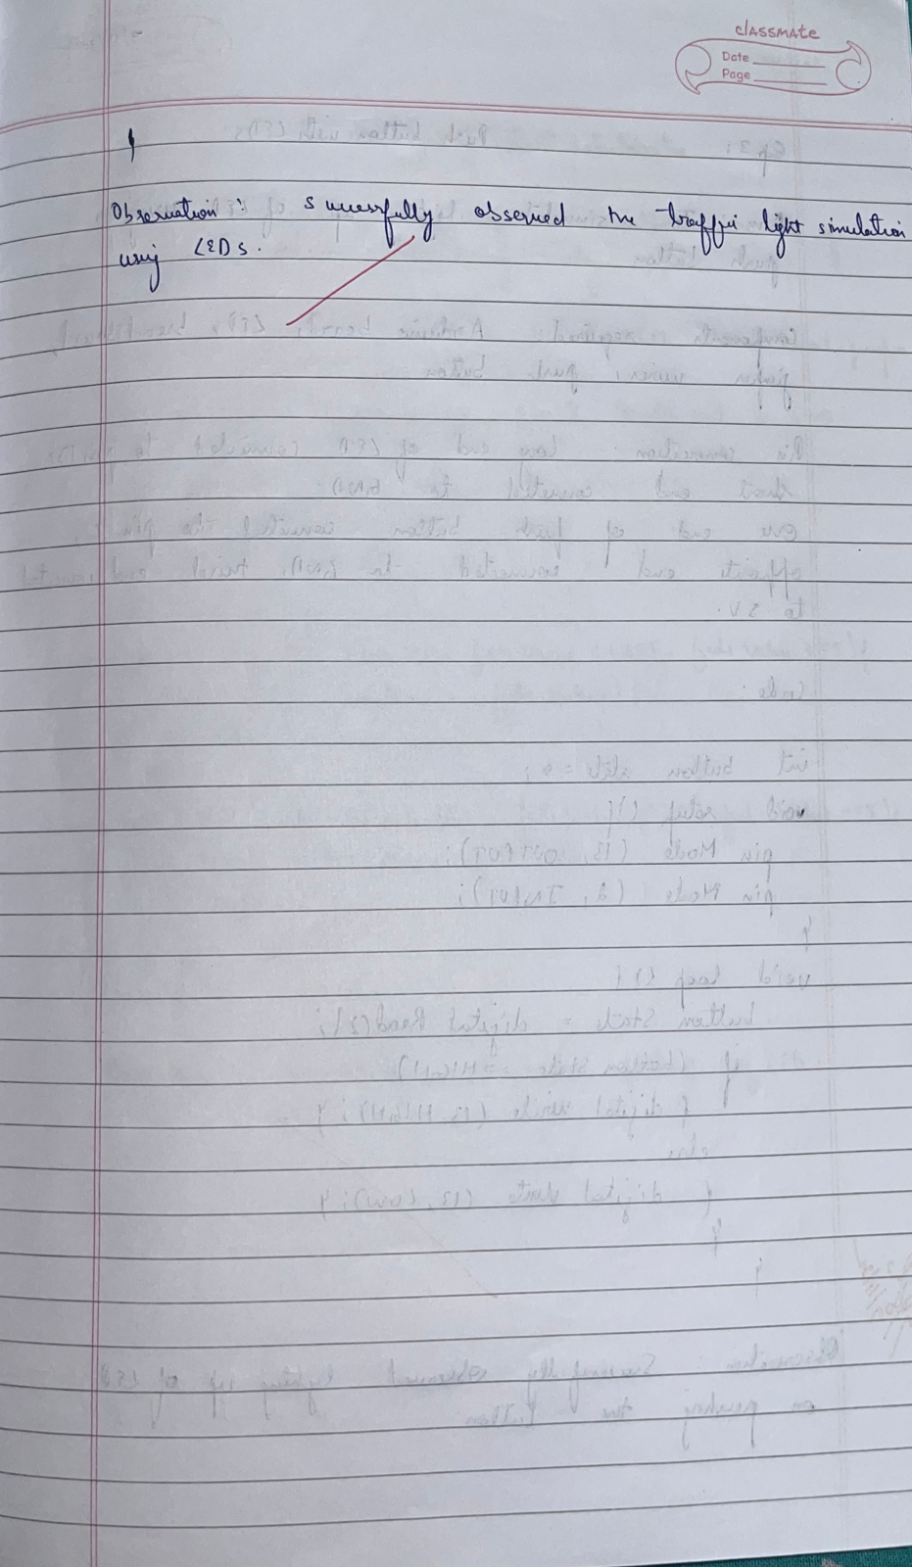

**Code:**

void setup() {

pinMode(9,OUTPUT);

pinMode(12,OUTPUT);

pinMode(8,OUTPUT);

}

void loop() {

digitalWrite(9,HIGH);

delay(1000);

digitalWrite(9,LOW);

delay(1000);

digitalWrite(12,HIGH);

delay(1000);

digitalWrite(12,LOW);

delay(1000);

digitalWrite(8,HIGH);

delay(1000);

digitalWrite(8,LOW);

delay(1000);

}

**Observation:** Successfully observed the traffic light simulation using LEDs.

Program no: **03**                        Program Title: **Push Button with LED**

**Aim:** To simulate glowing of LEDs using a push button.

**Hardware/components Required:**

* Arduino Uno board - 1
* USB Cable - 1
* LED - 1
* Jumper wires
* Bread Board
* Push Button

**Circuit Diagram / Pin connection:**

* LED’s positive leg is connected to digital pin 13, negative end to ground.
* One end of push button connect to pin 2, opposite end connected to ground.
* Third end of push button connected to 5v supply.

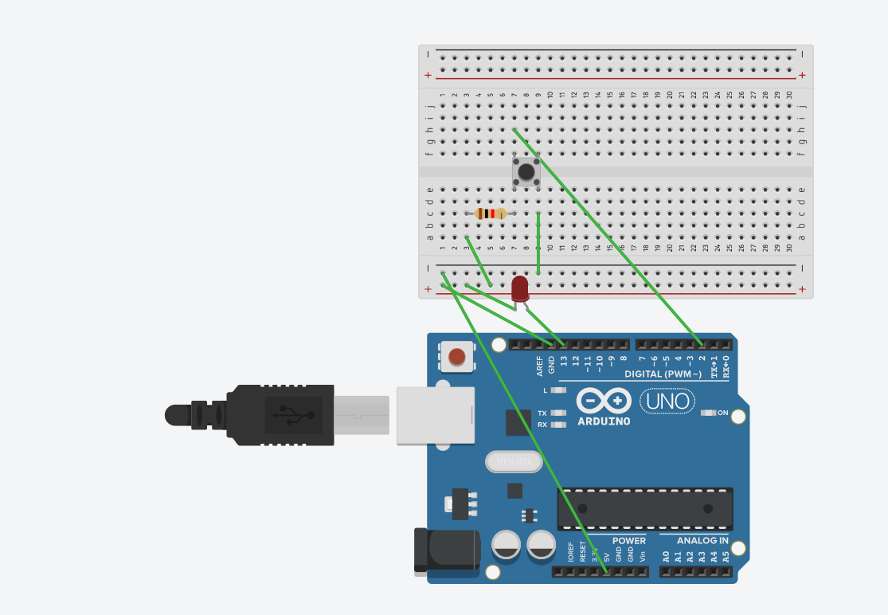

**Handwritten code pic:**

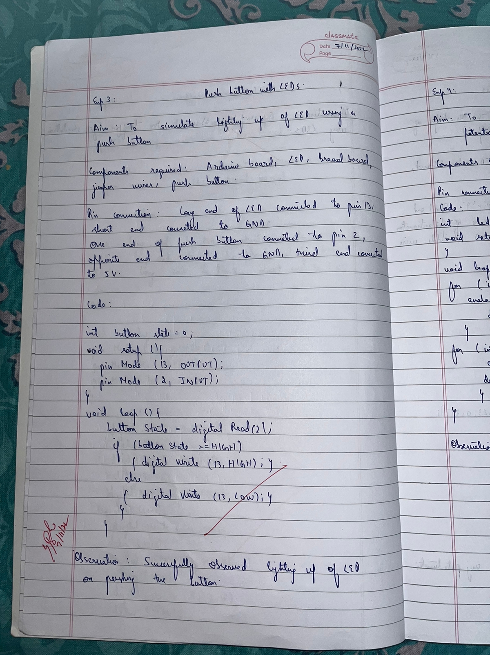

**Code:**

int buttonState= 0;

const int buttonPin =2;

const int ledPin =13;

void setup() {

pinMode(ledPin,OUTPUT);

pinMode(buttonPin,INPUT);

}

void loop() {

buttonState =digitalRead(buttonPin);

if(buttonState==HIGH){

digitalWrite(ledPin,HIGH);

}

else{

digitalWrite(ledPin, LOW);

}

}

**Observation:** Successfully observed the glowing of LED on pushing the button.

Program no: **04**                        Program Title: **LED fading without Potentiometer**

**Aim:** To simulate fading of LEDs without the use of potentiometer.

**Hardware/components Required:**

* Arduino Uno board - 1
* USB Cable - 1
* LED - 1
* Jumper wires
* Bread Board

**Circuit Diagram / Pin connection:**

* LED’s positive leg is connected to digital pin 9, negative end to ground.

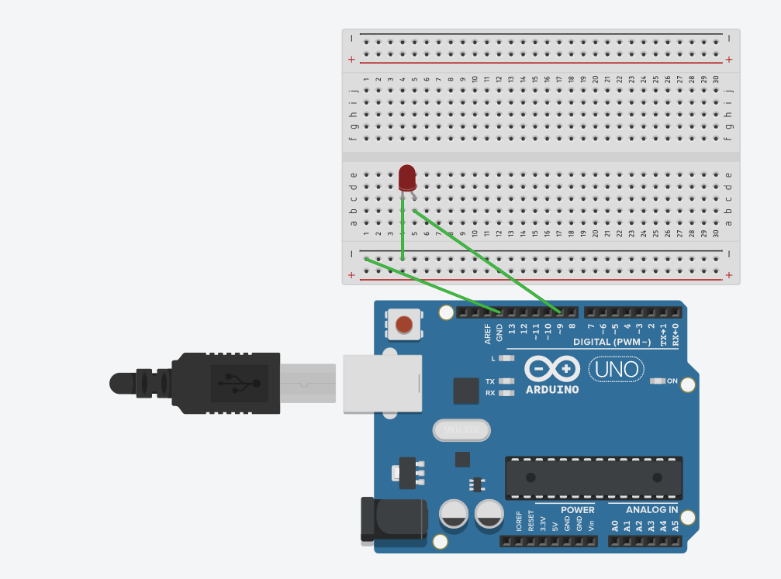

**Handwritten code pic:**

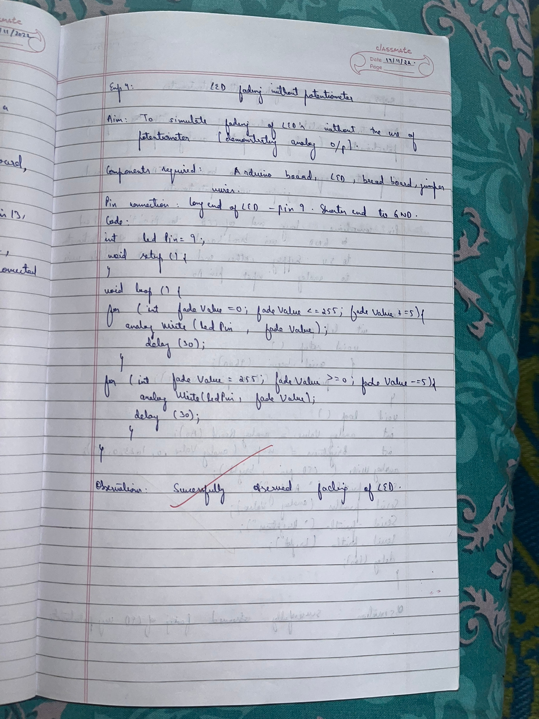

**Code:**

int ledPin = 9;

void setup() {

}

void loop() {

for (int fadeValue = 0; fadeValue <= 255; fadeValue += 5) {

analogWrite(ledPin, fadeValue);

delay(30);

}

for (int fadeValue = 255; fadeValue >= 0; fadeValue -= 5) {

analogWrite(ledPin, fadeValue);

delay(30);

}

}

**Observation:** Successfully observed the fading of LED without the use of potentiometer.

Program no: **05**                        Program Title: **LED fading with Potentiometer**

**Aim:** To simulate fading of LEDs without the use of potentiometer.

**Hardware/components Required:**

* Arduino Uno board - 1
* USB Cable - 1
* LED - 1
* Jumper wires
* Bread Board
* Potentiometer

**Circuit Diagram / Pin connection:**

* LED’s positive leg is connected to digital pin 9, negative end to ground.
* One end of potentiometer to 5v supply other end to ground.
* Middle wire of potentiometer to analog input pin A0.

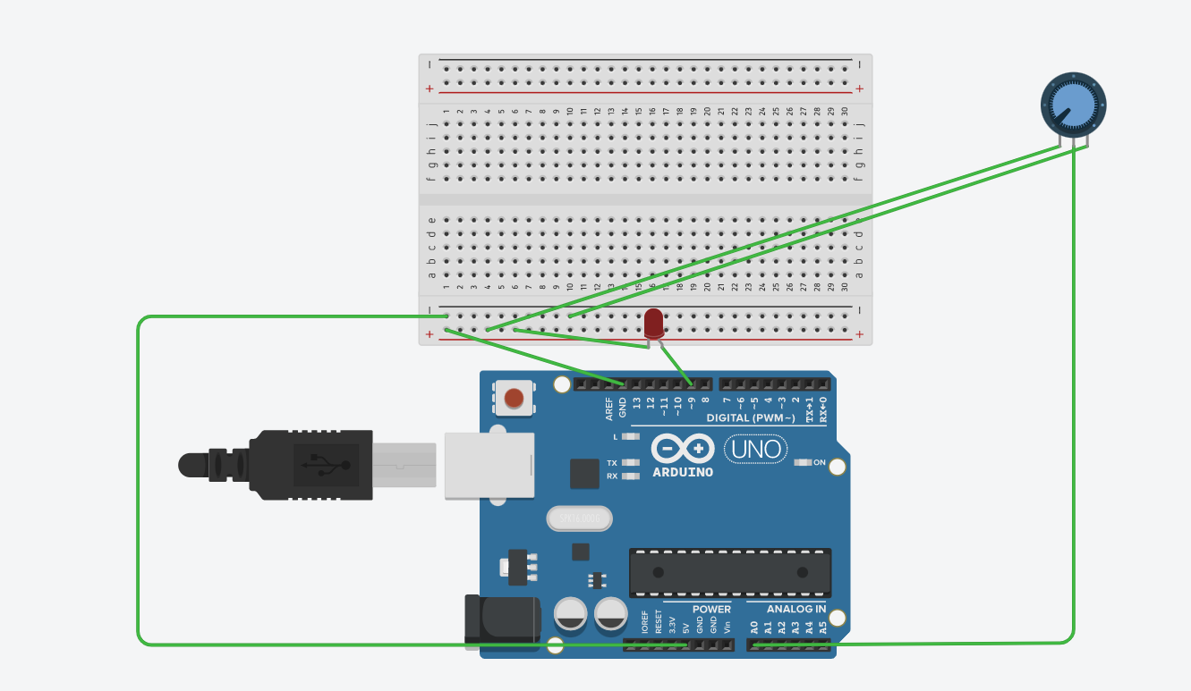

**Handwritten code pic:**

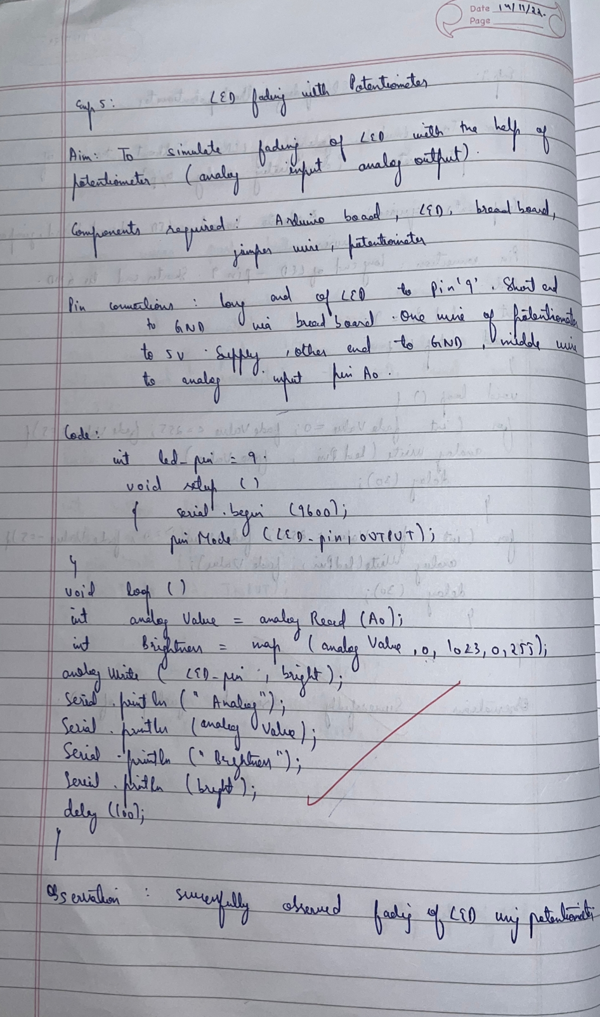

**Code:**

int ledPin = 9;

void setup()

{

Serial.begin(9600);

pinMode(ledPin,OUTPUT);

}

void loop()

{

int analogValue = analogRead(A0);

int brightness = map(analogValue,0,1023,0,255);

analogWrite(ledPin,brightness);

Serial.print("Analog");

Serial.print(analogValue);

Serial.print("brightness");

Serial.print(brightness);

delay(100);

}

**Observation:** Successfully observed the fading of LED by turning the shaft of the potentiometer.

Program no: **06**                  Program Title: **Fading effect of two LEDs using two Potentiometers**

**Aim:** To simulate fading of two LEDs without the use of potentiometer.

**Hardware/components Required:**

* Arduino Uno board - 1
* USB Cable - 1
* LEDs - 2
* Jumper wires
* Bread Board

**Circuit Diagram / Pin connection:**

* LED 1’s positive leg is connected to digital pin 9, negative end to ground.
* LED 2’s positive leg is connected to digital pin 6, negative end to ground.

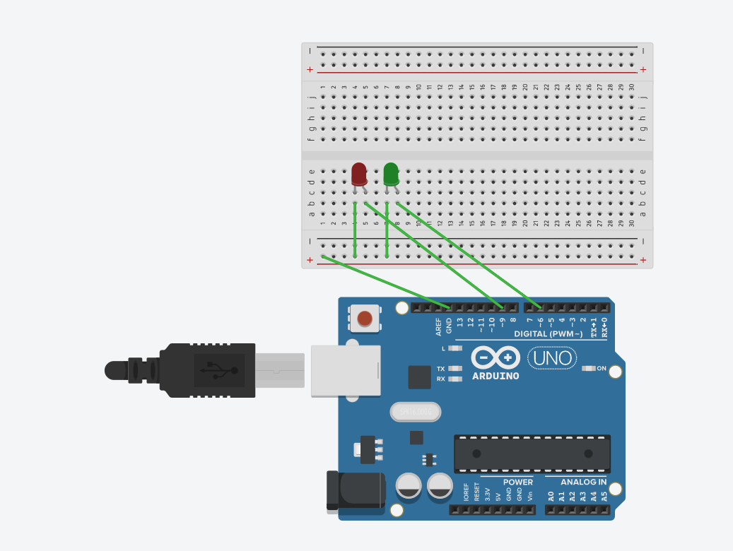

**Handwritten code pic:**

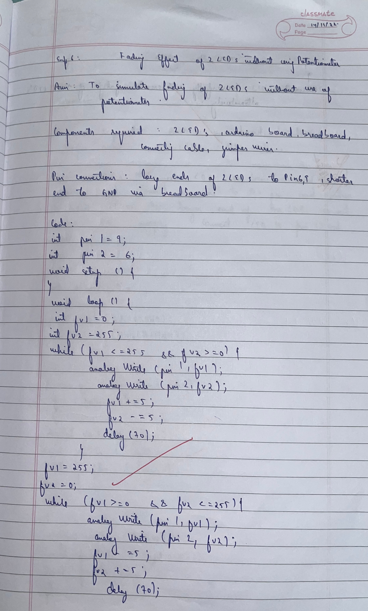

**Code:**

int ledpin1 = 9;

int ledpin2 = 6;

void setup(){

}

void loop()

{

int fadevalue1 =0;

int fadevalue2 =255;

while(fadevalue1 <=255&& fadevalue2>=0)

{

analogWrite(ledpin1,fadevalue1);

analogWrite(ledpin2,fadevalue2);

fadevalue1 +=5;

fadevalue2 -=5;

delay(70);

}

fadevalue1 =255;

fadevalue2 =0;

while(fadevalue1>=0 && fadevalue2<=255)

{

analogWrite(ledpin1,fadevalue1);

analogWrite(ledpin2,fadevalue2);

fadevalue1 -=5;

fadevalue2 +=5;

delay(70);

}

}

**Observation:** Successfully observed the fading of two LEDs alternatively without using potentiometer.

Program no: **07**                        Program Title: **LDR with LED**

**Aim:** To observe the slow of LED when the LDR is covered.

**Hardware/components Required:**

* Arduino Uno board - 1
* USB Cable - 1
* LED - 1
* Jumper wires
* Bread Board
* LDR - 1

**Circuit Diagram / Pin connection:**

* Connect shorter end of LED to ground, longer end of LED to pin 13
* Connect shorter end of LDR to A0 pin as well as ground via breadboard
* Connect longer end of LDR to 5v supply

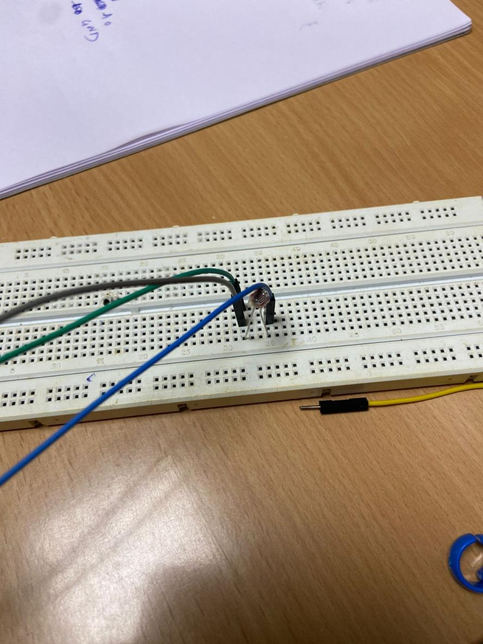

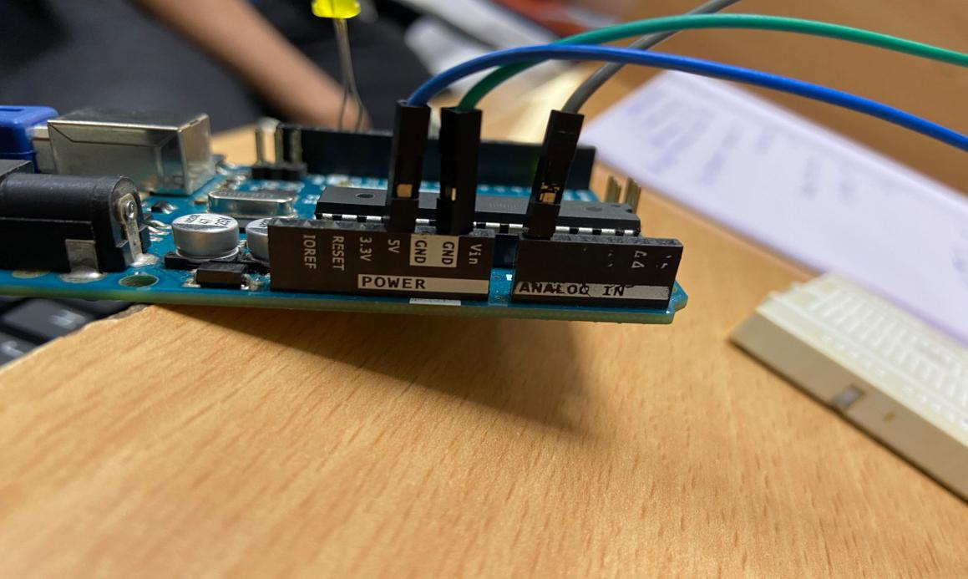

**Handwritten code pic:**

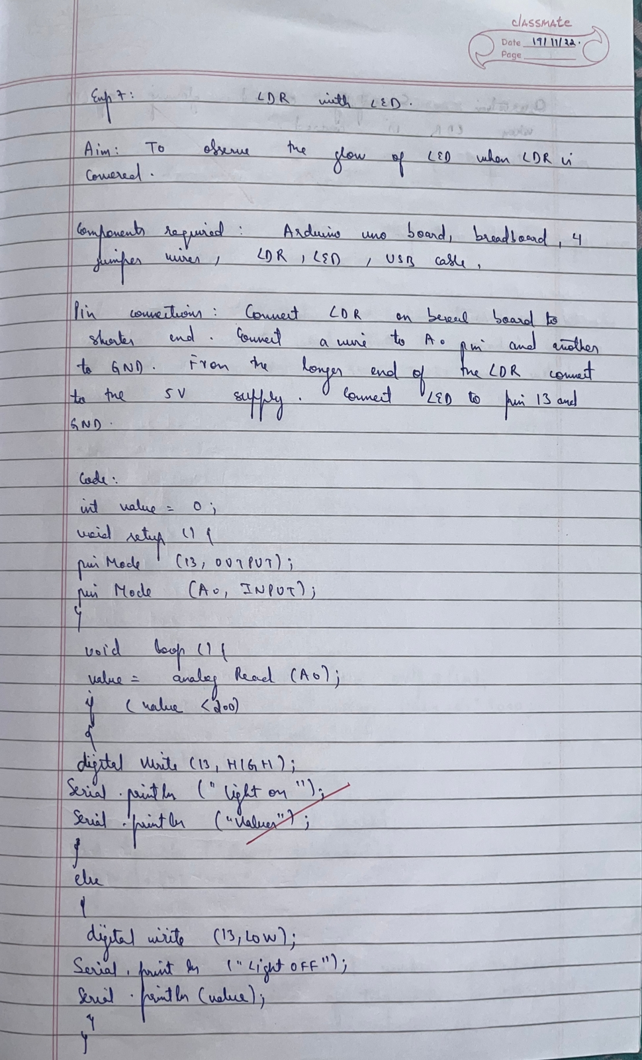

**Code:**

int value =0;

void setup()

{

Serial.begin(9600);

pinMode(13,OUTPUT);

pinMode(A0,INPUT);

}

void loop()

{

value = analogRead(A0);

if(value<200)

{

digitalWrite(13,HIGH);

Serial.println("light on");

Serial.println(value);

}

else

{

digitalWrite(13,LOW);

Serial.println("light off");

Serial.println(value);

}

}

**Observation:** Successfully observed the glowing of LED when the LDR was covered.

Program no: **08**                        Program Title: **LM35 Temperature Sensor**

**Aim:** To observe the working of temperature sensor and convert to Fahrenhiet

**Hardware/components Required:**

* Arduino Uno board - 1
* USB Cable - 1
* LM35 Temperature Sensor
* Jumper wires
* Bread Board

**Circuit Diagram / Pin connection:**

* Place the temperature sensor flat side facing us.
* Right end of LM35 will be grounded, left end will be connected to 5v supply.
* Middle end will be connected to A0 pin.

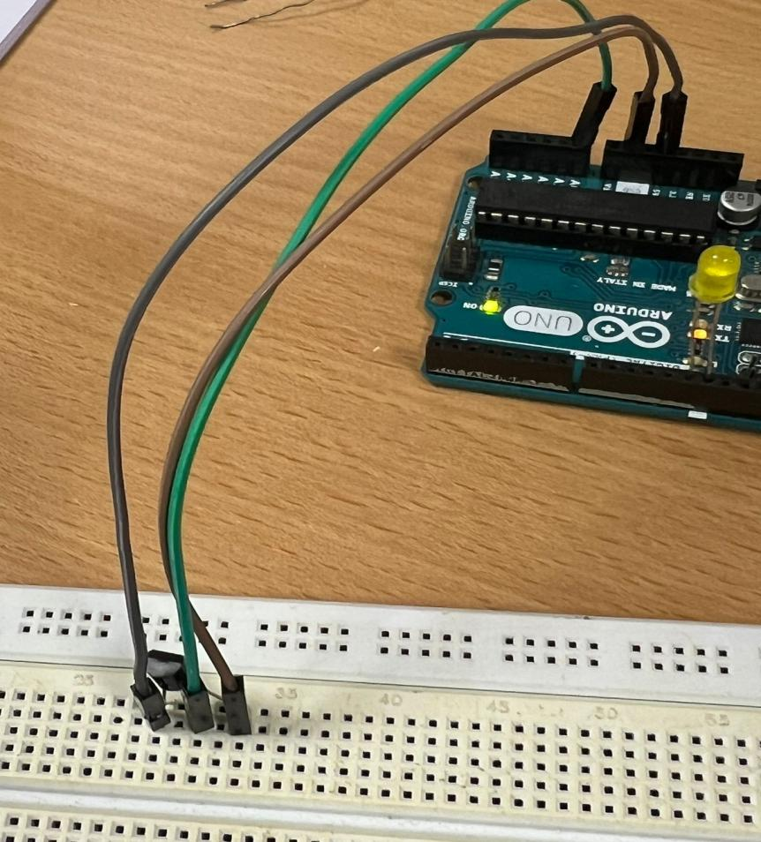

**Handwritten code pic:**

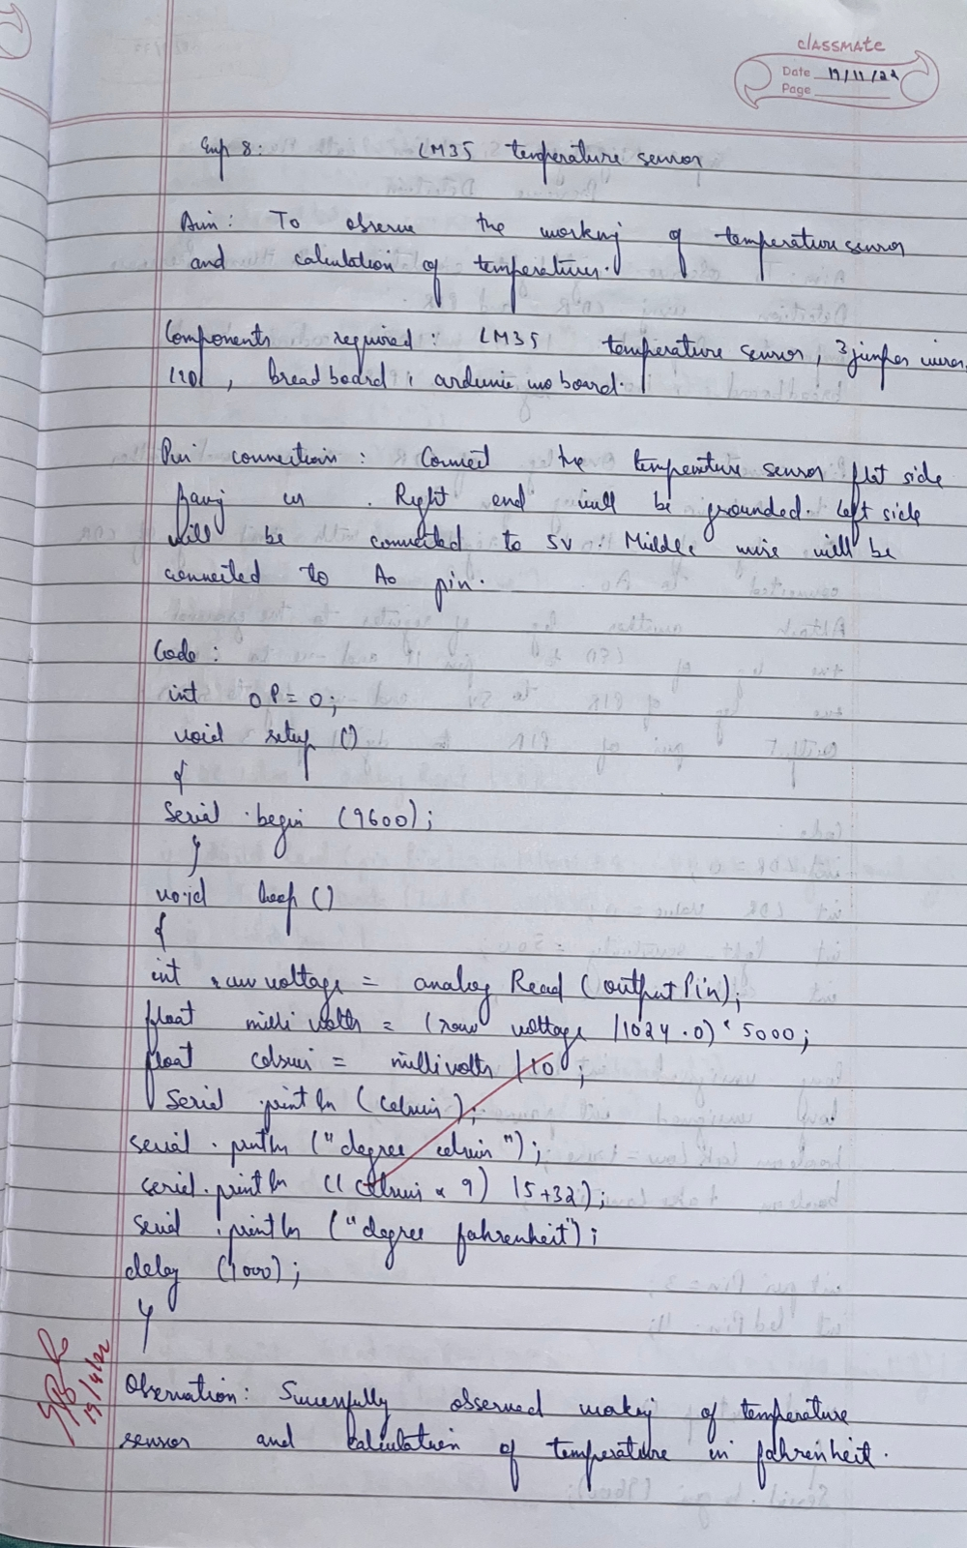

**Code:**

int outputpin=0;

void setup()

{

Serial.begin(9600);

}

Void loop()

{  
int rawvoltage=analogRead(outputpin);

float millivolts=(rawvoltage / 1024.0) * 5000;

float celsius - millivolts/10;

serial.print(celsius);

serial.print(“degree celsius”);

serial.print((celsius * 9)/5 + 32);

serial.print(“degrees fahrenheit”);

Delay(1000);

}

**Observation:** Successfully observed the calculation of temperature in Fahrenheit.

Program no: **9**                  Program Title: **Night Light Simulation with Human Presence Detection**

**Aim:** To observe night light simulation with human presence detection using LDR and PIR.

**Hardware/components Required:**

* Arduino Uno board - 1
* USB Cable - 1
* LEDs - 3
* Jumper wires
* Bread Board
* LDR - 1
* PIR - 1
* 110k Resistor

**Circuit Diagram / Pin connection:**

* Attach one leg of LDR to 5V and another leg to Arduino Analog pin A0
* Attach one leg of 110K register with that leg of LDR connected to A0
* Attach another leg of register to the ground
* Connect the positive leg of LED to pin 11 and negative to GND
* Connect positive leg of PIR to 5V and negative leg to GND
* Connect output pin of PIR to digital pin 3

**Handwritten code pic:**

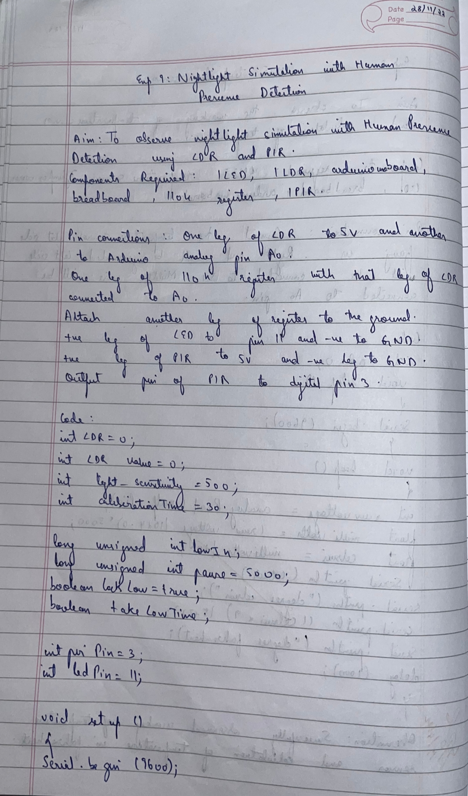

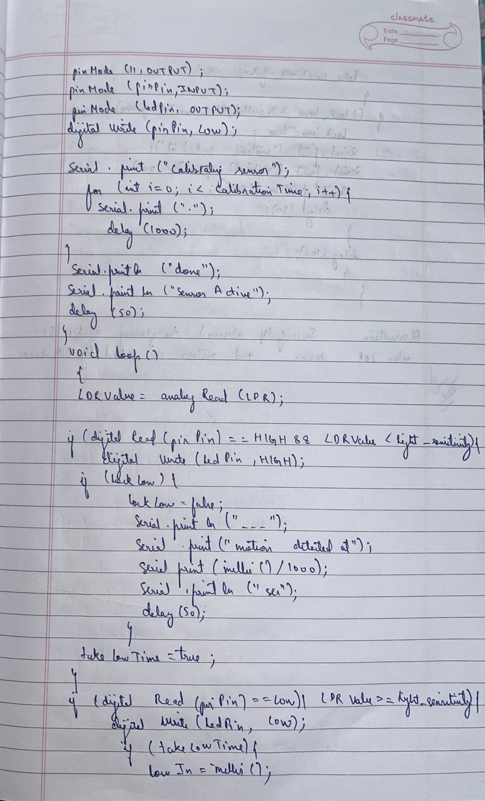

**Code:**

int LDR = 0;

int LDRValue = 0;

int light_sensitivity = 500;

int calibrationTime = 30;

long unsigned int lowIn;

long unsigned int pause = 5000;

boolean lockLow = true;

boolean takeLowTime;

int pirPin = 3;

int ledPin = 11;

void setup()

  {

Serial.begin(9600);

pinMode(11, OUTPUT);

    pinMode(pirPin, INPUT);

    pinMode(ledPin, OUTPUT);

    digitalWrite(pirPin, LOW);

Serial.print("calibrating sensor ");

    for(int i = 0; i<calibrationTime; i++){

        Serial.print(".");

        delay(1000);

     }

     Serial.println(" done");

     Serial.println("SENSOR ACTIVE");

     delay(50);

  }

void loop()

  {

LDRValue = analogRead(LDR);

 Serial.println(LDRValue);

     if(digitalRead(pirPin) == HIGH && LDRValue < light_sensitivity){

        digitalWrite(ledPin, HIGH);

        if(lockLow){

            lockLow = false;

            Serial.println("---");

            Serial.print("motion detected at ");

            Serial.print(millis()/1000);

            Serial.println(" sec");

            delay(50);

         }

        takeLowTime = true;

      }

      if(digitalRead(pirPin) == LOW ||  LDRValue >= light_sensitivity){

          digitalWrite(ledPin, LOW);

          if(takeLowTime){

            lowIn = millis();

            takeLowTime = false;

        }

      if(!lockLow&&millis() - lowIn> pause){

        lockLow = true;

        Serial.print("motion ended at ");

        Serial.print((millis() - pause)/1000);

        Serial.println(" sec");

        delay(50);

    }

      delay(100);

  }

}

**Observation:** Successfully observed the glowing of LED when LDR was covered and motion is sensed by the PIR.

Program no: **10**                        Program Title: **Ultra Sonic Sensor**

**Aim:** To observe and understand the working of the ultra sound sensor.

**Hardware/components Required:**

* Arduino Uno board - 1
* USB Cable - 1
* Jumper wires
* Bread Board
* HC-SR04

**Circuit Diagram / Pin connection:**

* Connect ground of HC-SR04 to ground of Arduino
* Connect Vcc of HC-SR04 to 5v supply of Arduino
* Connect trig pin to pin 7
* Connect echo pin to pin 6

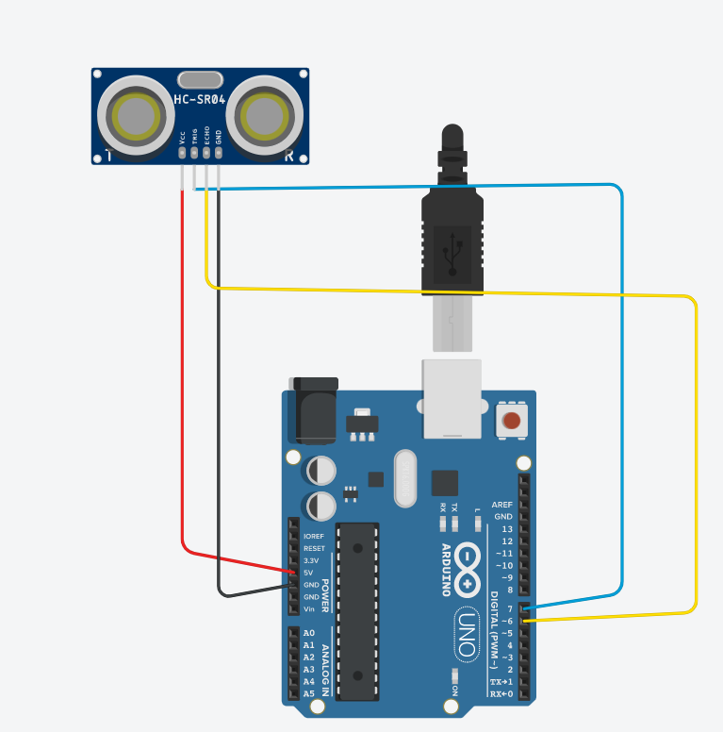

**Handwritten code pic:**

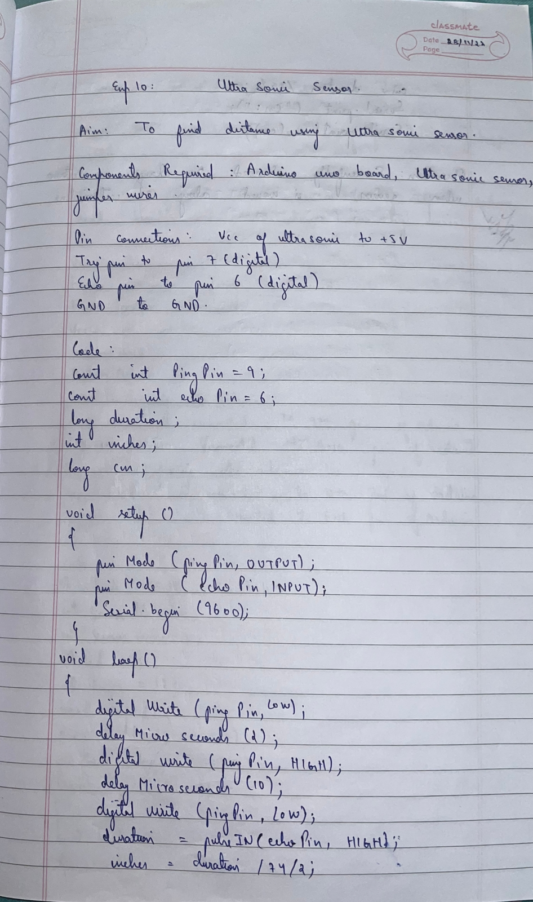

**Code:**

const int pingPin = 7;

echoPin = 6;

void setup()

{

Serial. begin(9600);

pinMode(pingPin, OUTPUT);

pinMode(echoPin, INPUT);

}

void loop()

{

long duration, inches, cm;

digitalWrite (pingPin, LOW);

delayMicroseconds(2);

digitalWrite (pingPin, HIGH);

delayMicroseconds(10);

digitalWrite (pingPin, LOW);

duration = pulseln(echoPin, HIGH);

inches = microsecondsTolnches(duration);

cm = microseconds ToCentimeters(duration);

}

Long microsecondsToinches(long microseconds)

{

return microseconds 174/2;  
}

Long microsecondsToinches(long microseconds)

{

return microseconds /74/2;  
}

Long microsecondsTocentimeters(long microseconds)

{

return /29/2;  
}

**Observation:** Successfully observed the distance of the obstacle from the sensor in cm.

Program no: **11**                        Program Title: **Fire Alert**

**Aim:** To simulate the working of fire alarm using buzzer and LED.

**Hardware/components Required:**

* Flame sensor (Analogue Output)
* Arduino
* Bread board
* LED
* Buzzer
* Connecting wires

**Circuit Diagram / Pin connection:**

**Flame sensor interfacing to Arduino**

Flame sensor to Arduino

vcc -> vcc

gnd -> gnd

A0 -> A0

**Led interfacing to Arduino**

**LED +ve** is connected to **9th pin** of Arduino

**LED -ve** is connected to **gnd pin** of arduino

**Buzzer interfacing to Arduino**

**Buzzer +ve** is connected to **12th pin** of Arduino

**Buzzer -ve** is connected to **GND** pin of Arduino

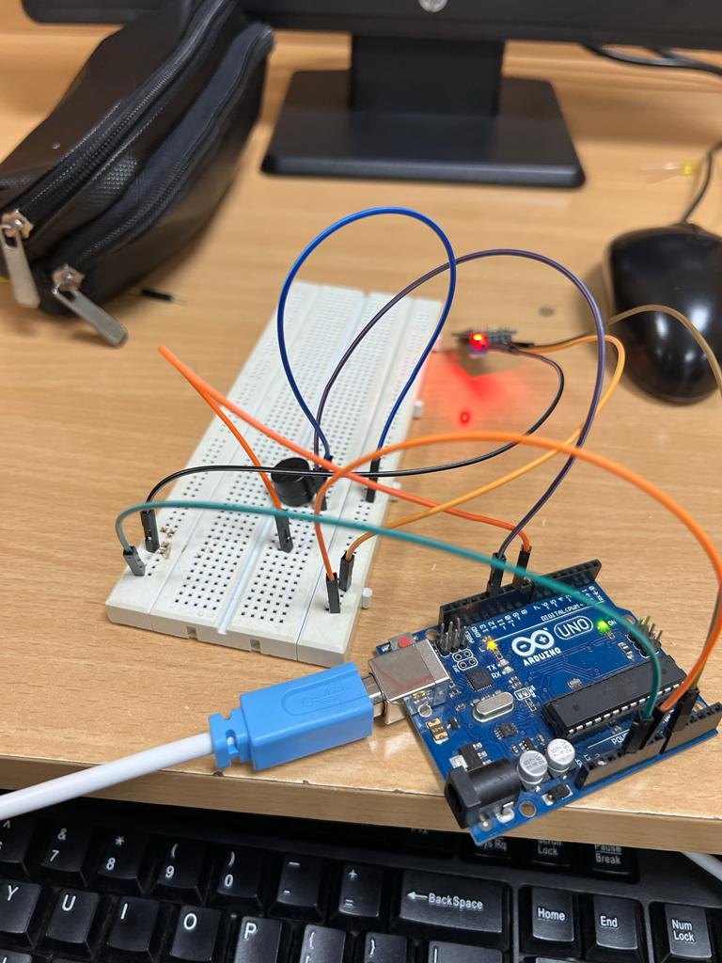

**Handwritten code pic:**

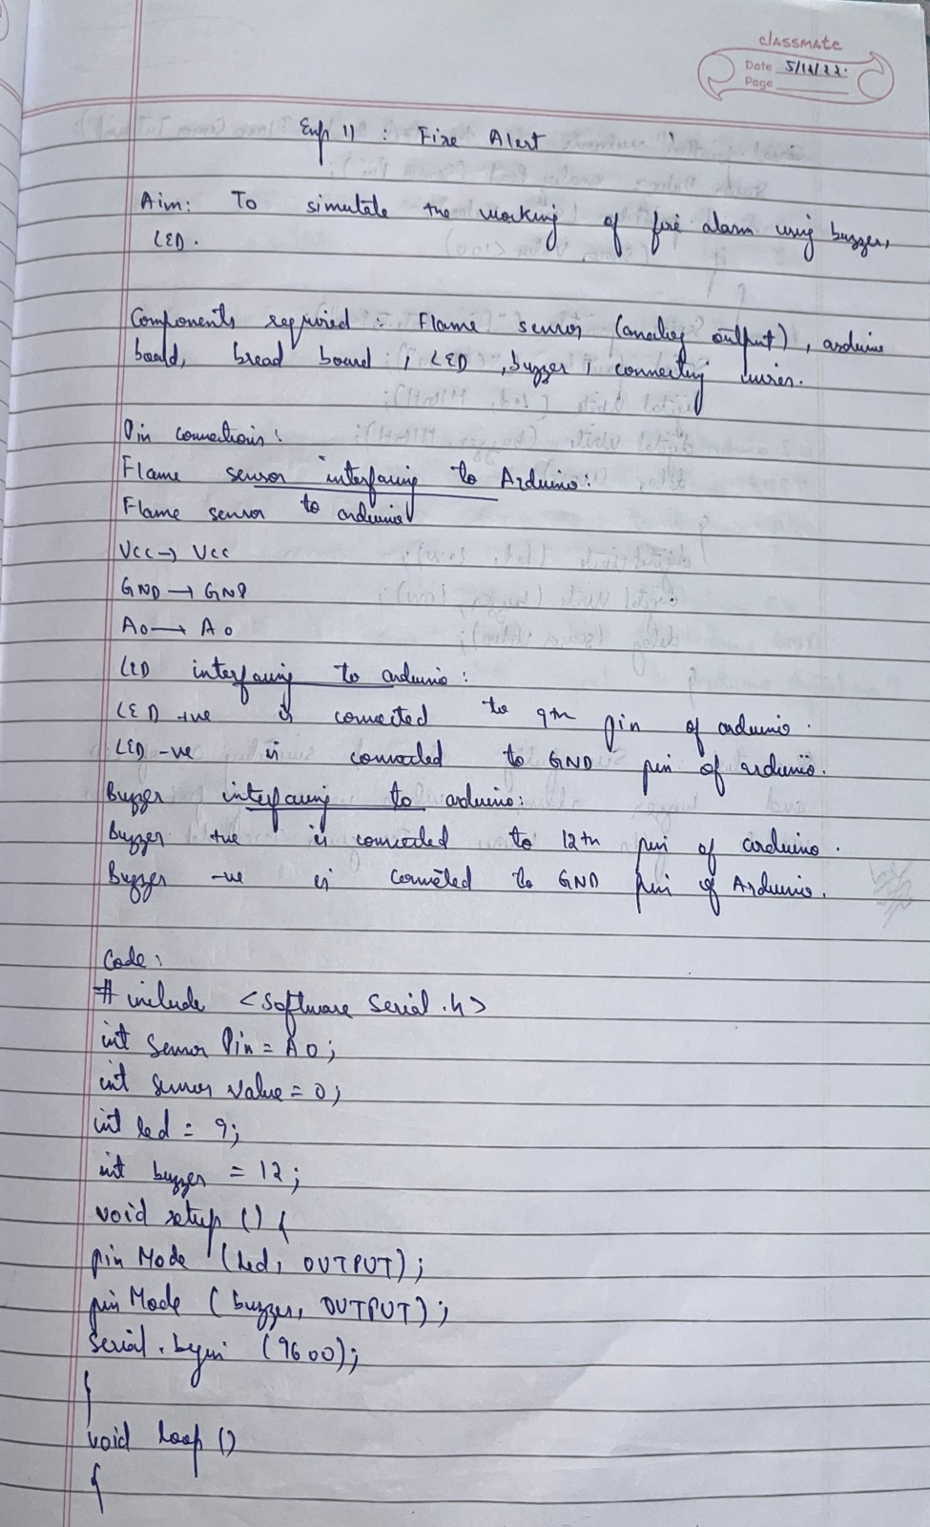

**Code:**

#include<SoftwareSerial.h>

int sensorPin = A0;

int sensorValue = 0;

int led = 9;

int buzzer = 12;

void setup() {

pinMode(led, OUTPUT);

pinMode(buzzer,OUTPUT);

Serial.begin(9600);

}

void loop()

{

Serial.println("Welcome to TechPonder Flame Sensor Tutorial");

sensorValue = analogRead(sensorPin);

Serial.println(sensorValue);

if (sensorValue < 100)

{

Serial.println("Fire Detected");

Serial.println("LED on");

digitalWrite(led,HIGH);

digitalWrite(buzzer,HIGH);

delay(1000);

}

digitalWrite(led,LOW);

digitalWrite(buzzer,LOW);

delay(sensorValue);

}

**Observation:** Successfully observed the blinking of LED and buzzing of buzzer when flame was detected by flame sensor.

Program no: **12**                     Program Title: **Automatic Irrigation Controller Simulation**

**Aim:** Sensing the soil moisture and sprinkling the water simulation.

**Hardware/components Required:**

* Arduino Uno board - 1
* USB Cable - 1
* Moisture Sensor
* Mini Servo Motor
* Jumper wires
* Bread Board

**Circuit Diagram / Pin connection:**

* Moisture sensor VCC to Arduino 5V
* Moisture sensor GND to Arduino GND
* Moisture sensor A0 to Arduino A0
* Servo motor VCC to Arduino 5V
* Servo motor GND to Arduino GND
* Servo Motor Signal to Arduino digital pin 9

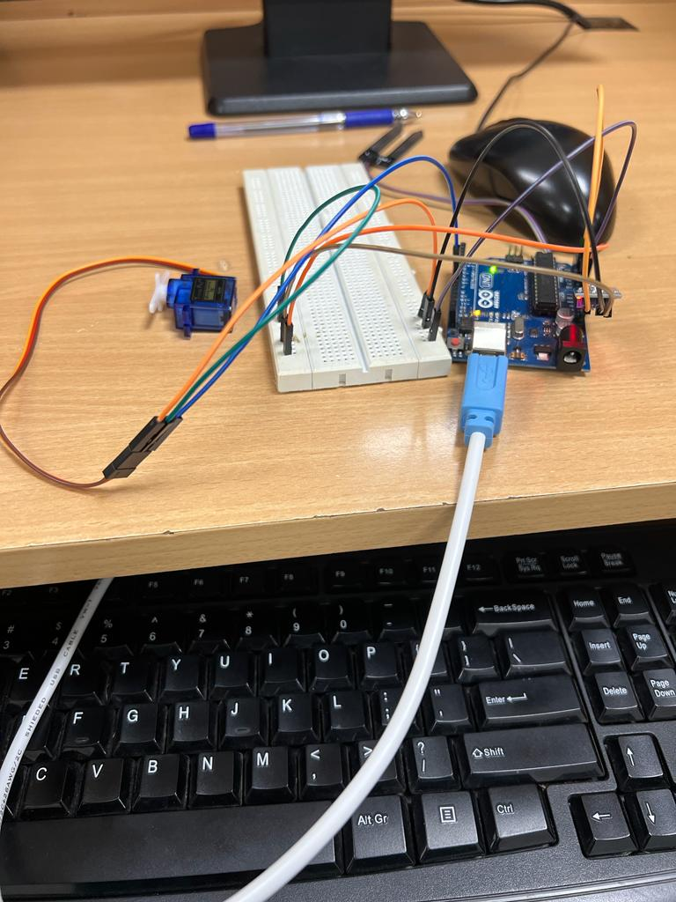

**Handwritten code pic:**

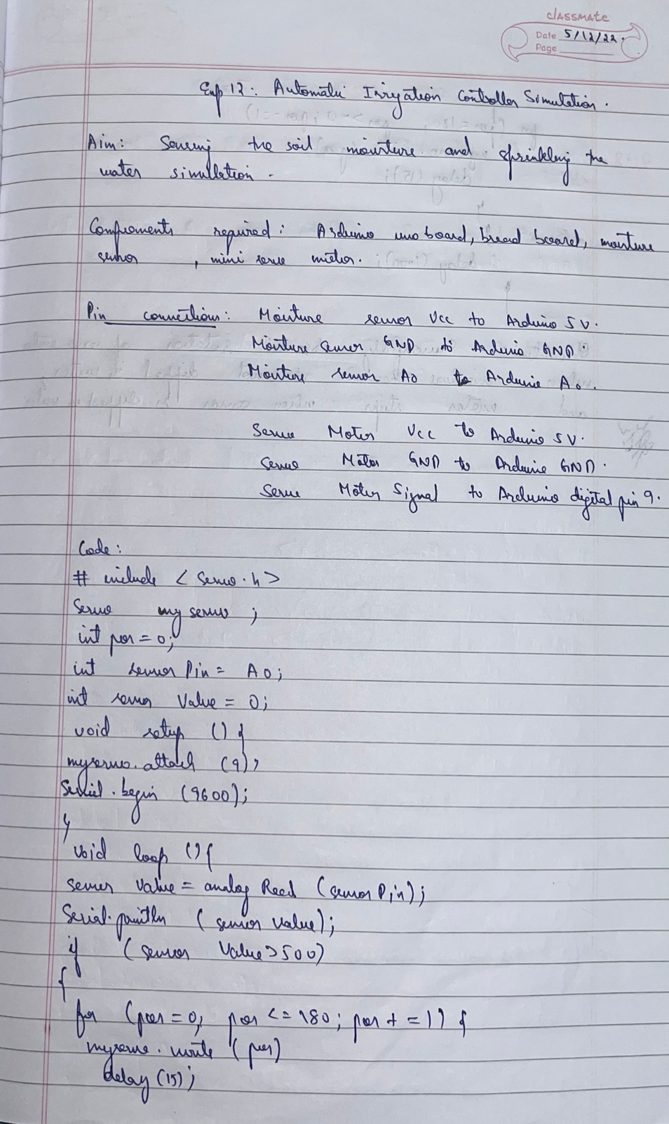



**Code:**

#include <Servo.h>

Servo myservo;

int pos = 0;

int sensorPin = A0;

int sensorValue = 0;

void setup() {

 myservo.attach(9);

Serial.begin(9600);

}

void loop() {

  sensorValue = analogRead(sensorPin);

Serial.println (sensorValue);

if(sensorValue>500)

{

  for (pos = 0; pos <= 180; pos += 1) {

    myservo.write(pos);

    delay(15);

  }

  for (pos = 180; pos >= 0; pos -= 1) {

    myservo.write(pos);

    delay(15);

  }

}

delay (1000);

}

**Observation:** Successfully observed the rotation of motor when the moisture sensor is not in contact with water. And observed the stopping of motor when the mositure sensor is in contact with water.

Program no: **13**                        Program Title: **RFID Reader**

**Aim:** To count the number of RFID tags read by the RFID reader

**Hardware/components Required:**

* Arduino Uno board - 1
* USB Cable - 1
* Jumper wires
* Bread Board
* RFID Reader module
* RFID Tags

**Circuit Diagram / Pin connection:**

* Ground of RFID to ground of Arduino Uno board.
* TX of RFID to RX(9) of Arduino.

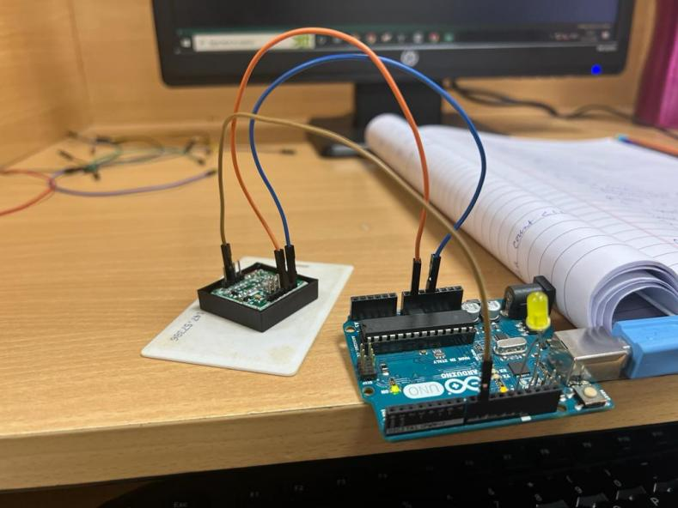

**Handwritten code pic:**

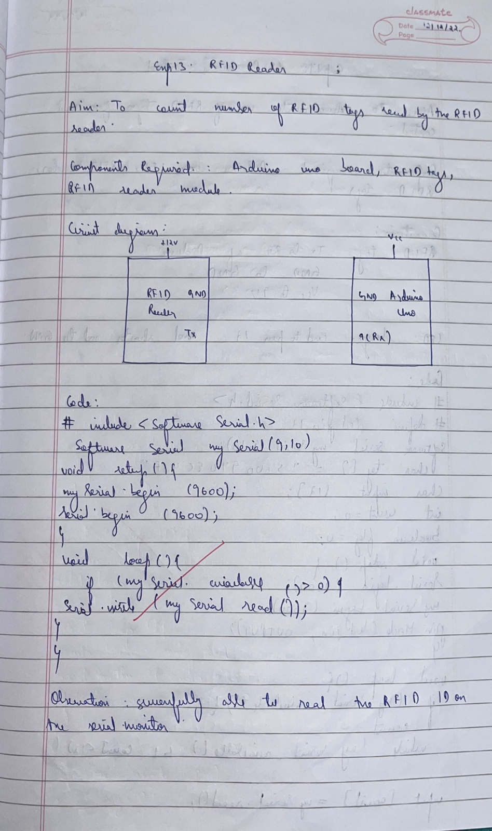

**Code:**

#include <SoftwareSerial.h>

SoftwareSerial mySerial(9, 10);

void setup()

{

mySerial.begin(9600);

Serial.begin(9600); }

void loop()

{

if(mySerial.available()>0)

{

Serial.write(mySerial.read());

}

}

**Observation:** Was successfully able to read the RFID ID on the serial monitor.

Program no: **14**                        Program Title: **RFID Access control**

**Aim:** To demonstrate the use of RFID tags for access control.

**Hardware/components Required:**

* Arduino Uno board - 1
* USB Cable - 1
* Jumper wires
* Bread Board
* RFID Reader
* RFID Tag

**Circuit Diagram / Pin connection:**

* RFID TX to Rx of Arduino
* Ground of RFID reader to ground of Arduino
* VCC of RFID to 5v supply of Arduino
* Longer end of LED to pin 12 and shorter end to Ground

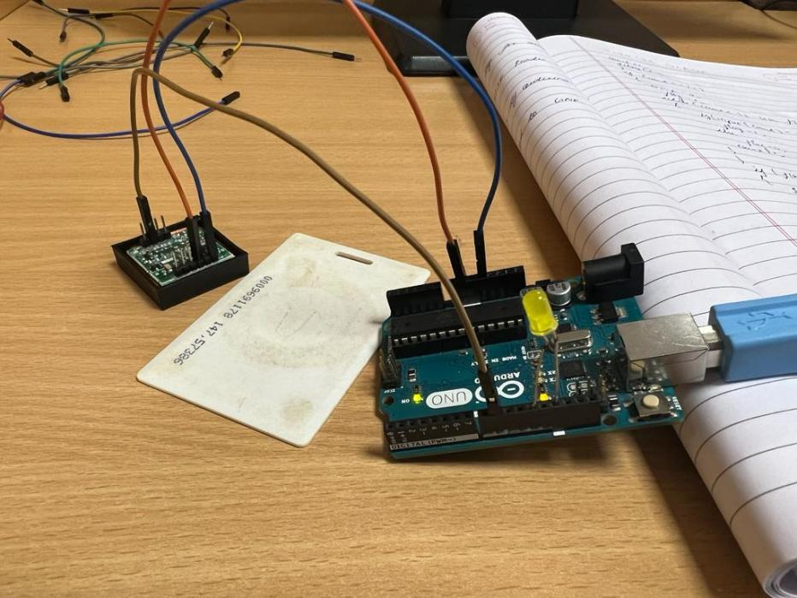

**Handwritten code pic:**

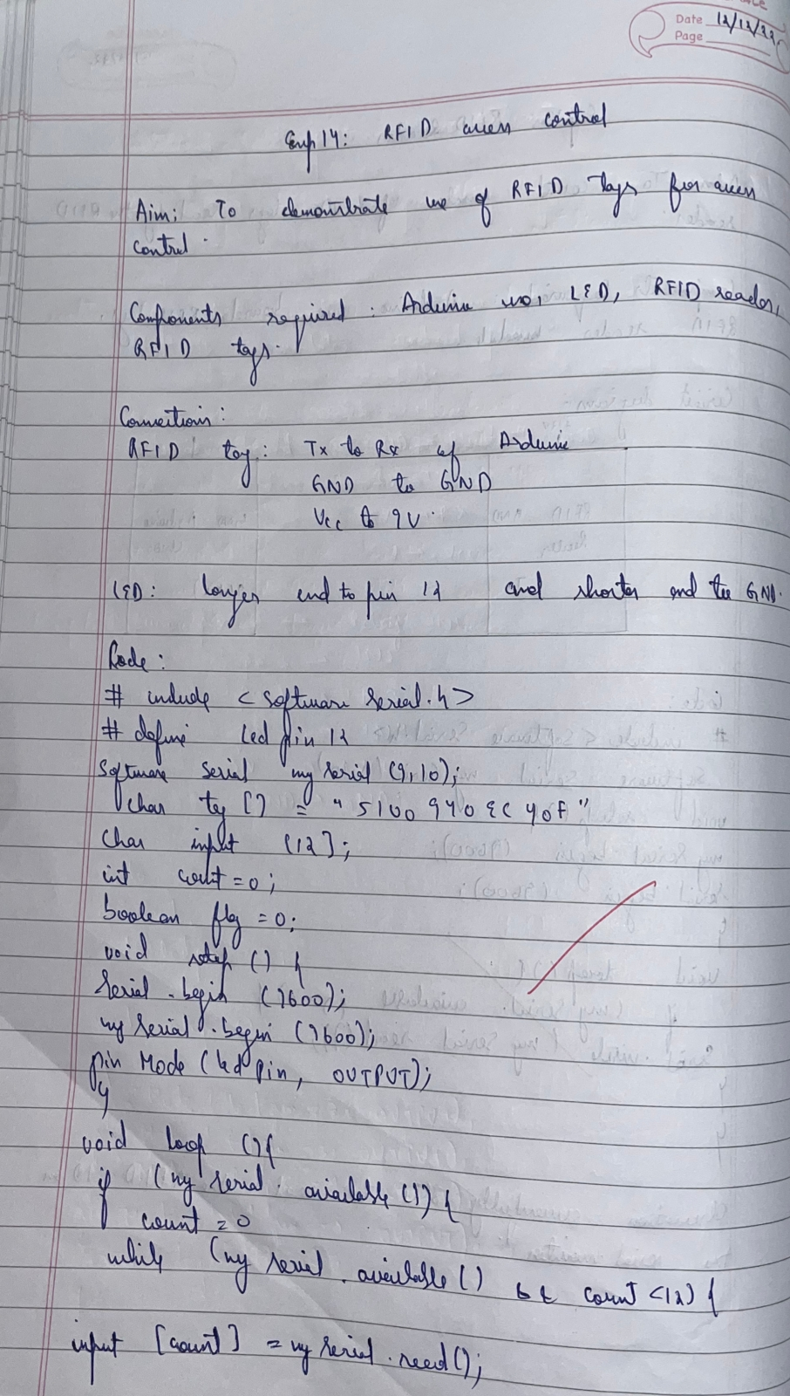

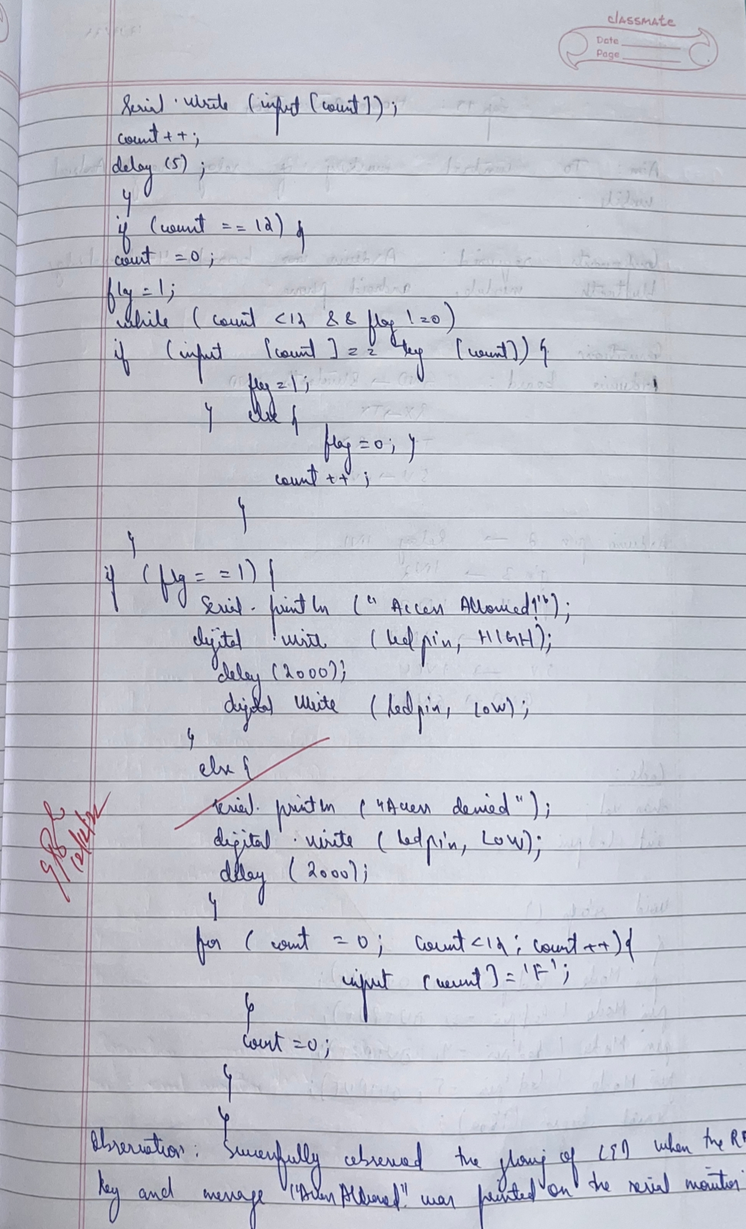

**Code:**

#include<SoftwareSerial.h>

SoftwareSerial mySerial(9, 10);

#define LEDPIN 12

char tag[] ="3C0087D597F9";

char input[12];

int count = 0;

input[] character array

boolean flag = 0;

void setup()

{ Serial.begin(9600);

mySerial.begin(9600);

pinMode(LEDPIN,OUTPUT); //WRONG TAG INDICATOR

}

void loop()

{

if(mySerial.available())

{

count = 0;

while(mySerial.available() && count < 12)

{

input[count] = mySerial.read();

Serial.write(input[count]);

count++; // increment counter

delay(5);

}

if(count == 12) //

{

count =0; // reset counter varibale to 0

flag = 1;

while(count<12 && flag !=0)

{

if(input[count]==tag[count])

flag = 1; // everytime the values match, we set the flag variable

to 1

else

flag= 0;

count++;

}

}

if(flag == 1)

{

Serial.println("Access Allowed!");

digitalWrite(LEDPIN,HIGH);

delay (2000);

digitalWrite (LEDPIN,LOW);

}

else

{

Serial.println("Access Denied");

digitalWrite(LEDPIN,LOW);

delay(2000);

}

for(count=0; count<12; count++)

{

input[count]= 'F';

}

count = 0; // Reset counter variable

}

}

**Observation:** Successfully observed the glowing of LED when the RFID key and message “Access Allowed” was printed on the serial monitor.

Program no: **15**                     Program Title: **Bluetooth Home Automation**

**Aim:** To control the working of relay through Android Mobile.

**Hardware Required:**

* Arduino
* 4-Channel relay
* Bluetooth Module
* Android phone

**Circuit Diagram / Pin connection:**

* Output 1 to Pin 4 ( Arduino Board )  
  Output 2 to Pin 5  
  Output 3 to Pin 6  
  Output 4 to Pin 7
* Bluetooth Module Tx to Pin 0  
  Bluetooth Module Rx to Pin 1
* VCC of Bluetooth & relay should be connected to Arduino 5V(through breadboard)
* GND of Bluetooth & relay should be connected to Arduino GND

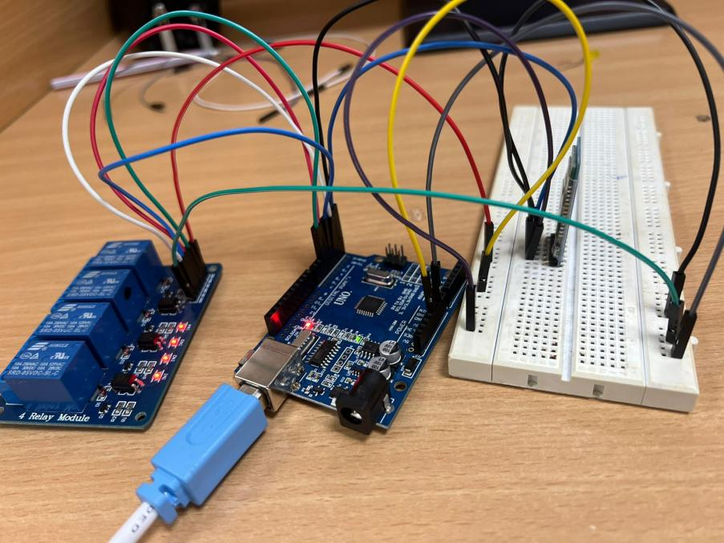

**Handwritten code pic:**

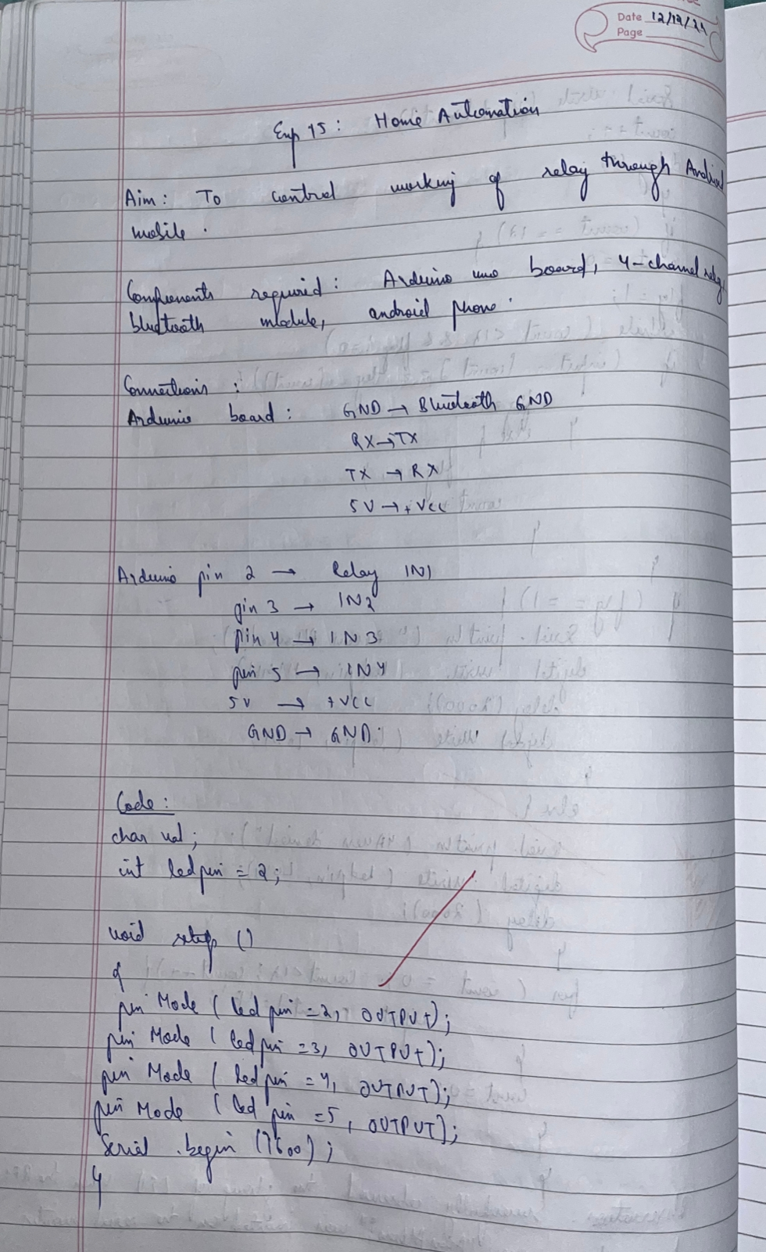

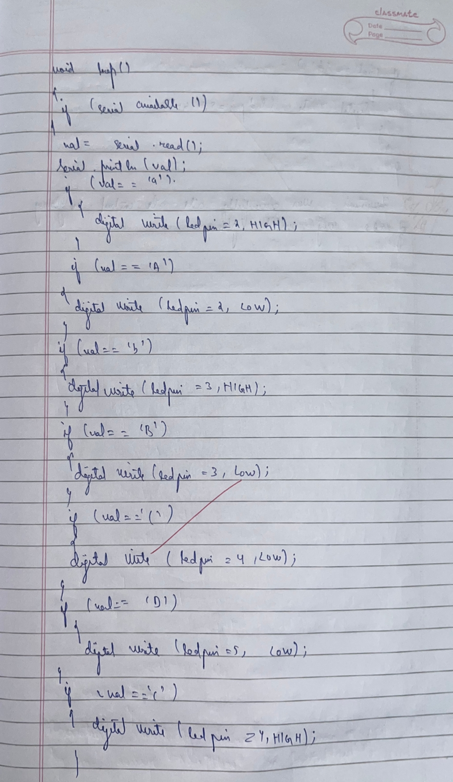



**Code:**

char val;

int ledpin = 2;

void setup()

{

pinMode(ledpin = 2, OUTPUT);

pinMode(ledpin = 3, OUTPUT);

pinMode(ledpin = 4, OUTPUT);

pinMode(ledpin = 5, OUTPUT);

Serial.begin(9600);

}

void loop()

{

if( Serial.available() )

{

;

}

val = Serial.read();

if( val == 'a' )

{

digitalWrite(ledpin = 2, HIGH);

}

if( val == 'A' )

{

digitalWrite(ledpin = 2, LOW);

}

if( val == 'b' )

{

digitalWrite(ledpin = 3, HIGH);

}

if( val == 'B' )

{

digitalWrite(ledpin = 3, LOW); }

if( val == 'C' )

{

digitalWrite(ledpin=4, LOW);

}

if( val == 'D' )

{

digitalWrite(ledpin=5, LOW);

}

if( val == 'c' )

{

digitalWrite(ledpin = 4, HIGH);

}

if( val == 'd' )

{

digitalWrite(ledpin = 5, HIGH);

}

}

**Observation:** Was successfully able to control the glowing of LEDs using mobile phone.

Program no: **16**                        Program Title: **Working with GSM Module**

**GSM Module: Call to a particular number**

**Hardware/components Required:**

* Arduino Uno board - 1
* USB Cable - 1
* **SIM900 GSM Module**
* Jumper wires
* Bread Board

**Aim:** Call using Arduino and GSM Module – to a specified mobile number inside the program.

**Circuit Diagram / Pin connection:**

* GSM Tx –>Arduino Rx (Here pin 2)
* GSM Rx –>Arduino Tx. (Here pin 3)
* Make the ground common between Arduino and GSM modem.

**Handwritten code pic:**

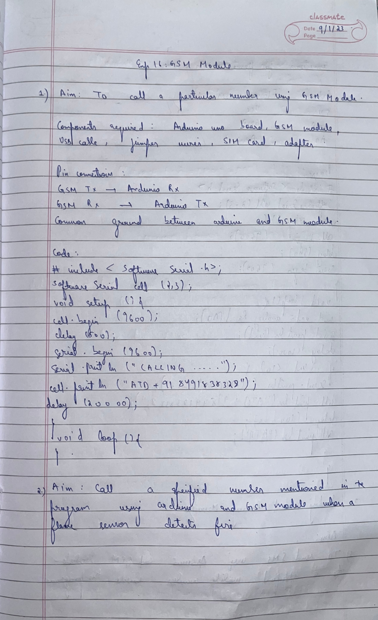

**Code:**

#include <SoftwareSerial.h>

SoftwareSerial cell(2,3); // (Rx, Tx)

void setup() {

cell.begin(9600);

delay(500);

Serial.begin(9600);

Serial.println("CALLING..........");

**cell.println("ATD+9538433364;");**

delay(20000);

}

void loop() {

}

**Call to a particular number on an alert**

**Aim**: Call a specified mobile number mentioned in the program using Arduino and GSM Module when a flame sensor detects “fire”.

**Connections for flame sensor:**

**Arduino Flame Sensor**

5V VCC

GND GND

A0 A0

**Handwritten code pic:**

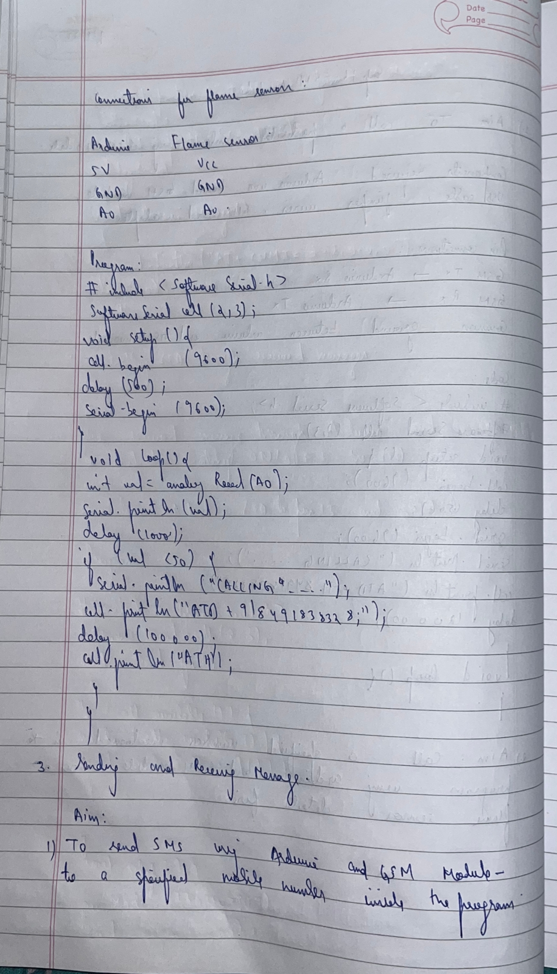

**Code:**

#include <SoftwareSerial.h>

SoftwareSerialcell(2,3);

void setup() {

cell.begin(9600);

delay(500);

Serial.begin(9600);

}

void loop() {

Int val=analogRead(A0);

Serial.println(val);

delay(1000);

if (val<50)

{

Serial.println("CALLING..........");

**cell.println("ATD+919742980606;");**

delay(10000);

**cell.println("ATH"); // Attention Hook Control**

}

}

**Sending and Receiving Message**

**Aim:**

1) Send SMS using Arduino and GSM Module – to a specified mobile number inside the program

2) Receive SMS using Arduino and GSM Module – to the SIM card loaded in the GSM Module.

**Handwritten code pic:**

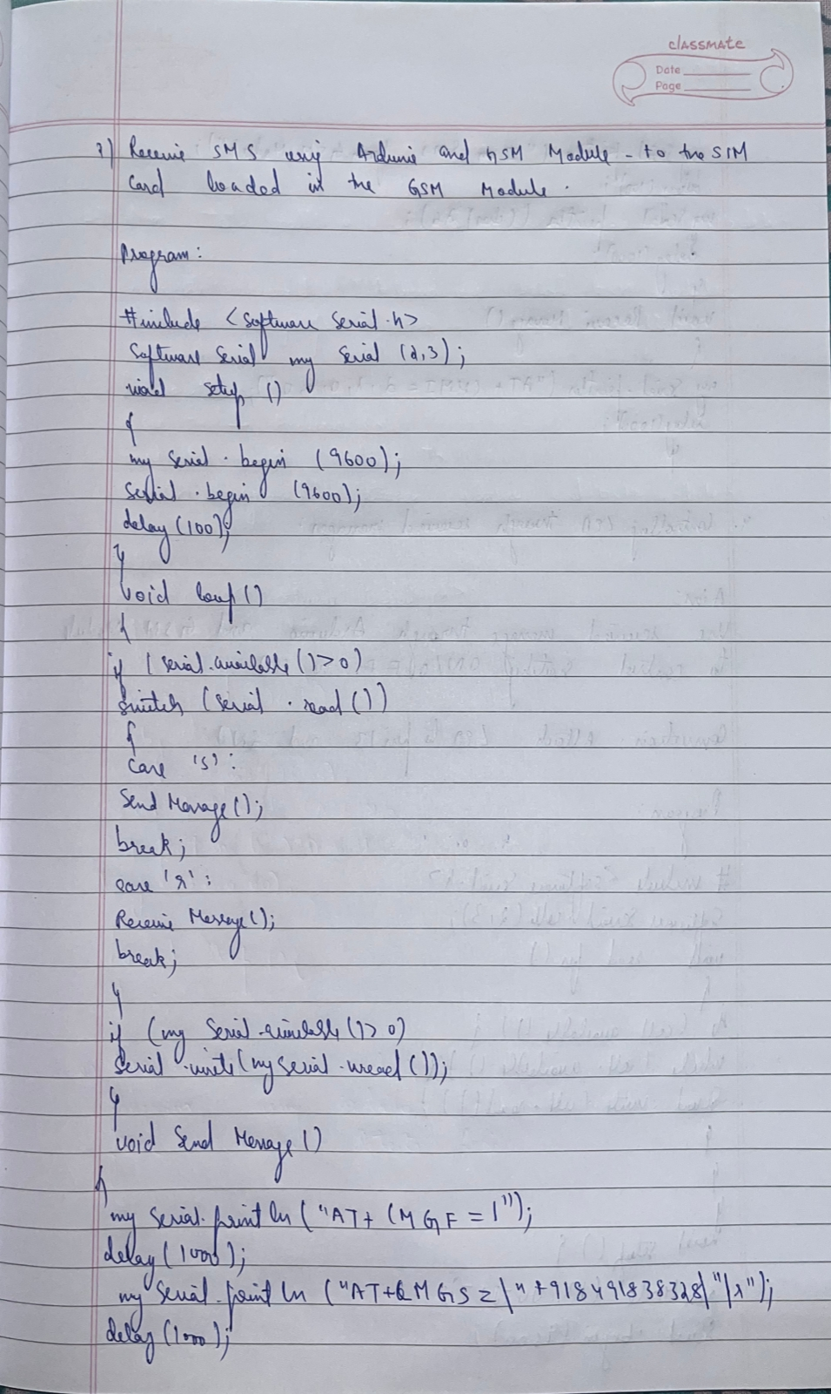

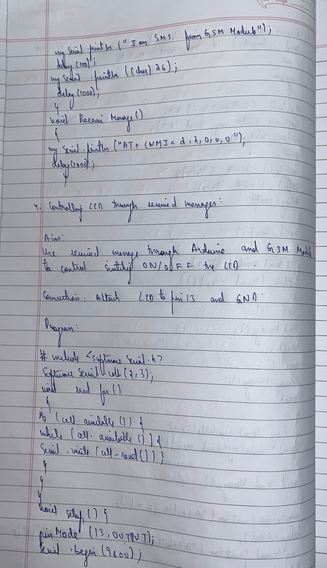

**Code:**

#include <SoftwareSerial.h>

SoftwareSerial mySerial(2, 3);

void setup()

{

mySerial.begin(9600); // Setting the baud rate of GSM Module

Serial.begin(9600); // Setting the baud rate of Serial Monitor (Arduino)

delay(100);

}

void loop()

{

if (Serial.available()>0)

switch(Serial.read())

{

case 's':

SendMessage();

break;

case 'r':

RecieveMessage();

break;

}

if (mySerial.available()>0)

Serial.write(mySerial.read());

}

void SendMessage()

{

mySerial.println("AT+CMGF=1");

delay(1000); // Delay of 1000 milli seconds or 1 second

mySerial.println("AT+CMGS=\"+919742980606\"\r");

delay(1000);

mySerial.println("I am SMS from GSM Module");

delay(100);

mySerial.println((char)26)**;**

delay(1000);

}

Void RecieveMessage()

{

mySerial.println("AT+CNMI=2,2,0,0,0");

delay(1000);

}

**Controlling LED through received messages:**

**Aim:**

Use received message through Arduino and GSM Module to control Switching ON / OFF the LED.

**Connection:**Attach LED to pin 13 and GND.

**Handwritten code pic:**



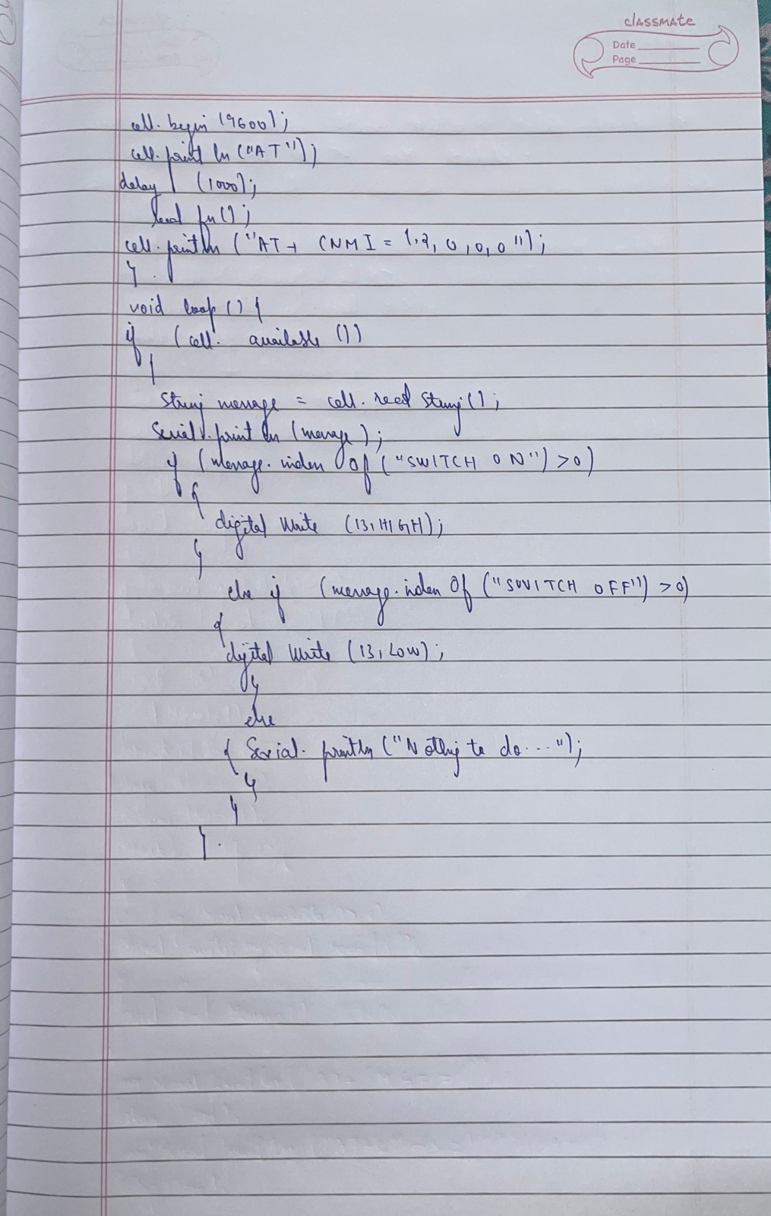

**Code:**

#include <SoftwareSerial.h>

SoftwareSerial cell(2,3);

void readfn()

{

if (cell.available()) {

while (cell.available()) {

Serial.write(cell.read());

}

}

}

void setup() {

pinMode(13,OUTPUT);

Serial.begin(9600);

cell.begin(9600);

cell.println("AT");

delay(1000);

readfn();

//New SMS alert

cell.println("AT+CNMI=1,2,0,0,0");

}

void loop() {

if(cell.available())

{

String message =cell.readString();

Serial.println(message);

if(message.indexOf("SWITCH ON")>0)

{

digitalWrite(13,HIGH);

}

else if(message.indexOf("SWITCH OFF")>0)

{

digitalWrite(13,LOW);

}

else

{

Serial.println ("Nothing to do...");

}

}

}